Nikita Annastasia Andrews

Address: #50 Richardson Trace, Pepper Village, Fyzabad

Telephone Number: (868) 299-1570 or (868) 749-4198

Best time of Day to contact: anytime

E-mail: [anna.andrews@hotmail.com](mailto:anna.andrews@hotmail.com)

Date of Birth: 28th December, 1986

Place of Birth: San Fernando General Hospital

Gender: Female

Country of Citizenship: Trinidadian

Field of Interest: Cashier

Date available to start: as soon as possible

Experience

2004 Detours Gulf City Mall Sales Clerk

2005-2008 Hilo Gulf City Cashier/Office Assistant/ MoneyGram Clerk

2008-2009 Tall “O” Mini Mart Manager/Owner

**2009-2014 Anand Low Price Group of Companies**

2009- 2010 Worked as a waitress (Sting Night Club) Anand Group of Companies

2010-2012 worked as a Cashier (Playdium) Anand Group Of Companies

2012-2014 worked as a Cashier/Payroll Administer/ Supervisor (The Rig) Anand Group of Companies

2012-2012 Pepper Village Gov’t Library Assistant

# Education

Pepper Village Government School 1991-1999

Siparia Junior Secondary School 1999-2002

Pleasantville Senior Secondary School 2002-2004 Typing (3)

Office Procedures (3)

Mathematics (4)

Modern Business School 2009 Computer Lit Basic

Computer Lit Advance

Siparia Secondary School 2012 On the Job Training Certificate

School of Practical Accounting 2013 Certificate Level

Institute for Health and Safety 2014 OSHA Certificate Level 1

Institute for Health and Safety 2014 Fire Watch Certificate

# References

Gregory Grant Petrotrin Police 868-776-8294

Elizabeth John PSCU Marketing Manager 868-368-2993

# Skills

Excellent communication and people skills, outstanding communicators, eager to learn and contribute.



Massy Stores  
South Trunk Road,  
Bamboo Bay,  
La Romain.  
Trinidad. W.I

**Dear Human Resource Manager**

My name is Nikita Annastasia Andrews, I were recently a Supervisor/Head Cashier at

the Rig Restaurant and Lounge, and at presently I am looking for a career change to

further my studies in Accounting, I would like to be considered for the **Cashier** position at your company Massy Stores Limited.

Throughout my Career I have demonstrated efficiency and exceptional people skills, I

am a people oriented individual with the ability to work under pressure while still putting

the customer service first. Due to my accounting experiences my portfolio at the Rig

Restaurant and Lounge includes weekly completion of employee’s payroll, invoice and

Secretarial skills. I obtain cxc past, Computer Literacy Advance Certificate, Accounting

Certificate, OJT (On the Job Training) Certificate, OSHA Certificate and Firewatch

Certificate.

My solid communication skills have given me the talent and knowledge necessary to

succeed and enrich your establishment. Thank you for considering me and I look

forward to your call an interview.

Yours Sincerely

....................................................

Nikita Andrews

193 PEPPER VILLAGE,

FYZABAD

FRIDAY 12TH SEPTEMBER 2014

TO WHOM IT MAY CONCERN

This is to certify that I have known NIKITA ANDREWS, of #50 Richardson Trace, Pepper Village Fyzabad, for the past 10 years, during which time I have always found her to be a most trustworthy, loyal and dedicated person, who always pursue means of improving herself. She has quite a sunny disposition and always applies her acquired knowledge to life situations, making her an asset in any customer oriented environment.

_______________________

GREGORY GRANT 777-8294

**Nikita Andrews Certificate of Character**

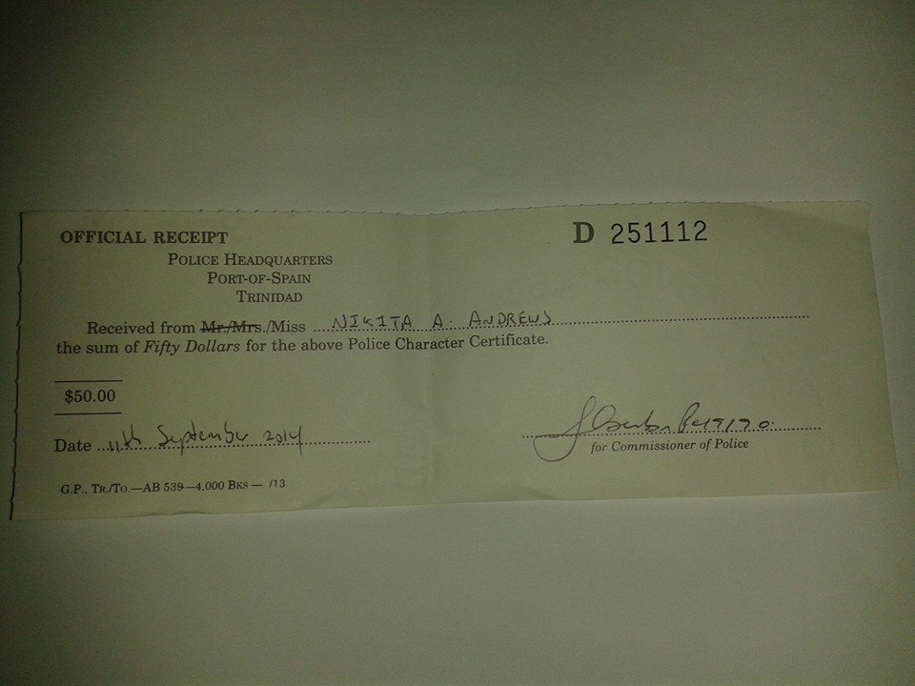

BANK RECORDS: RBC ROYAL BANK, GULF CITY, LA ROMAIN TRINIDAD

ACCOUNT # 100099171520936

HOLDER NAME: NIKITA ANNASTASIA ANDREWS

NIS # 02 143 8598

